SIMATS ENGINEERING

ASSESSMENT TOOL III – VISUALIZATION CRITIQUE & REDESIGN
Course: Data Handling and Visualization | Code: DSA0601 | CO: CO3
Duration: 120 min | Total Marks: 100 | Reg No:
Name: | JAANA NITHISH | 192324275

COURSE OUTCOME COVERED
CO3: Analyze time-series data, trends, associations, and uncertainty through appropriate visualization methods. (BL4) Activity Tool: Visualization Critique & Redesign Weightage: 20%
Code of Conduct:
I JAANA NITHISH(192324275) certify that this submission is my original work and that I have adhered to the guidelines specified for this assessment. I understand that any violation of academic integrity rules will result in disciplinary action.
Signature of the student: CHANIKYA

Criter ia | Evaluatio n of Existing Visualization  (25%) | Redesig n Strategy (25%) | Applicati on of Vis. Principle s  (20%) | Organiz ation (15%) | Accu racy (10%  ) | Clarity (5%) | Total
Q1
Q2
Q3
Q4
Q5

AT3 – Visualization Critique & Redesign

R Programming Assessment – Distribution and Proportion Visualization

Instructions: For each question, use R/RStudio to reproduce the given visualization, critique its effectiveness, identify misleading or inappropriate visual encodings, and redesign it using a more suitable visualization. Include the R code, redesigned visualization, and a concise justification of your design decisions.

Question 1 – Critique and Redesign an ECDF and Q-Q Plot
Dataset: Delivery_Time_Distribution.csv

Dataset:

Order_ID | Warehouse | Delivery_Time_Hrs
O01 | Chennai | 4
O02 | Chennai | 5
O03 | Chennai | 6
O04 | Chennai | 7
O05 | Chennai | 9
O06 | Bengaluru | 3
O07 | Bengaluru | 5
O08 | Bengaluru | 6
O09 | Bengaluru | 8
O10 | Bengaluru | 10
O11 | Hyderabad | 6

O12 | Hyderabad | 7
O13 | Hyderabad | 8
O14 | Hyderabad | 12
O15 | Hyderabad | 15
O16 | Pune | 4
O17 | Pune | 6
O18 | Pune | 8
O19 | Pune | 9
O20 | ZPune | 22

Assessment Task
A logistics analyst has created an ECDF and a Q-Q plot to study delivery time distribution across warehouses, but the charts use inconsistent axis scaling, missing reference lines, and cluttered gridlines.
- Create the two original-style plots in R.
- Identify at least three visualization problems.
- Redesign the plots using appropriate scales, labels, reference lines, and minimal visual clutter. 4. Explain how the redesigned plots improve interpretation of skewness, outliers, and normality. 5. State whether an ECDF plot alone is sufficient to detect outliers, or whether it should be paired with another plot.

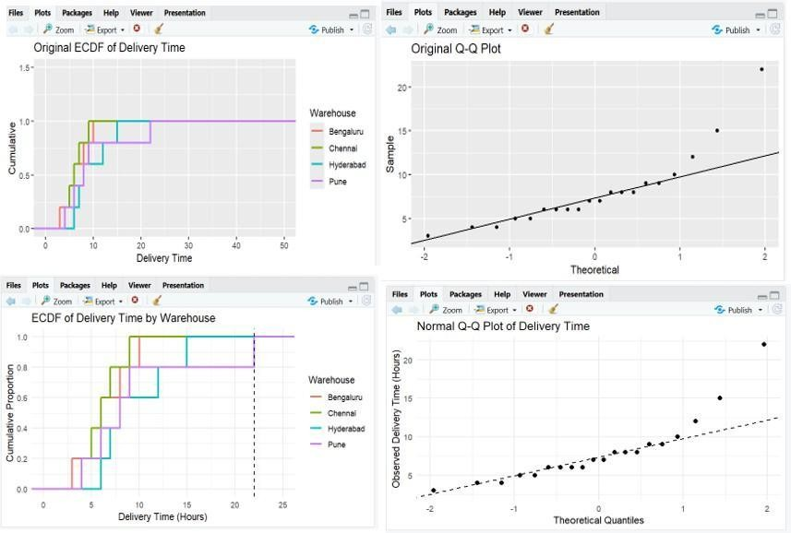

ECDF and Q-Q Plot
  - ECDF shows the cumulative distribution of delivery times.
  - Q-Q plot checks whether the data follows a normal distribution.
  - Original plots had inconsistent axis scaling and unnecessary clutter.
  - Redesigned plots use proper scales, clear labels, and reference lines.
  - The 22-hour delivery time appears to be a possible outlier.
  - The Q-Q plot helps identify skewness and deviations from normality.
  - ECDF alone is not sufficient for detecting outliers.
  - It should be combined with a boxplot or Q-Q plot.

Question 2 – Critique and Redesign Many Distributions Using Bean Plots

Dataset: Subject_Marks.csv

Dataset:

Student_ID | Subject | Marks
T01 | Physics | 58
T02 | Physics | 63

T03 | Physics | 70
T04 | Physics | 77
T05 | Physics | 85
T06 | Chemistry | 52
T07 | Chemistry | 60
T08 | Chemistry | 68
T09 | Chemistry | 74
T10 | Chemistry | 82
T11 | Mathematics | 61
T12 | Mathematics | 66
T13 | Mathematics | 73
T14 | Mathematics | 80
T15 | Mathematics | 90
T16 | Biology | 55
T17 | Biology | 62
T18 | Biology | 69
T19 | Biology | 76
T20 | Biology | 88

Assessment Task
An academic report uses four separate boxplots with different y-axis ranges to compare marks across subjects. The comparison is difficult because the scales and layouts are inconsistent.
- Reproduce the problematic visualization using R.
- Critique the use of separate boxplots, inconsistent scales, and truncated axes.
- Redesign the visualization using bean plots or a suitable
violin/density-based alternative. 4. Add an appropriate common scale and clear subject labels.
- Explain which subject has the highest concentration of marks and which subject shows the greatest spread.

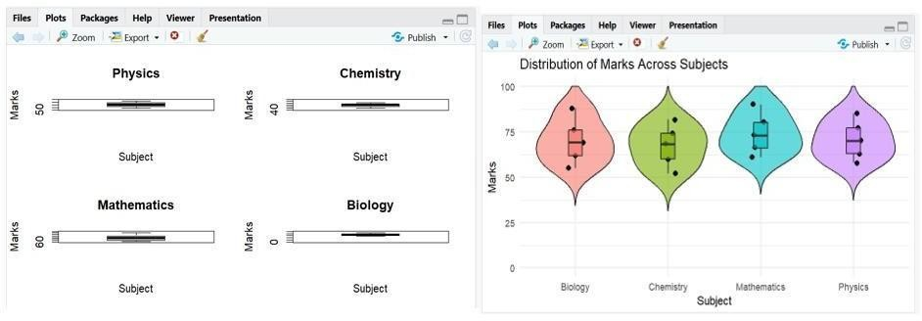

Bean/Violin Plot
  - Original visualization used separate boxplots with different scales.
  - Different y-axis ranges make comparisons misleading.
  - Truncated axes can exaggerate differences.
  - A combined violin/bean plot uses a common scale from 0 to 100.
  - All subject distributions can be compared easily in one chart.
  - Individual data points can also be displayed.

Mathematics shows the greatest spread in marks.
  - The redesigned visualization is clearer and more compact.

Question 3 – Critique and Redesign Proportion Visualizations
Dataset: App_Downloads.csv

Dataset:

City | App_Category | Downloads
Chennai | Games | 30

City | App_Category | Downloads
Chennai | Social | 42
Chennai | Utility | 18
Mumbai | Games | 35
Mumbai | Social | 38
Mumbai | Utility | 22
Delhi | Games | 26
Delhi | Social | 44
Delhi | Utility | 20
Kolkata | Games | 24
Kolkata | Social | 36
Kolkata | Utility | 29

Assessment Task
A marketing team presents app-category proportions using four pie charts, one for each city. The charts use exploded slices, mismatched color palettes, and inconsistent labeling.
- Create a representative version of the misleading visualization.
- Identify at least four design problems.
- Redesign the analysis using side-by-side bars and a 100% stacked bar chart.
- Compare the two redesigns and determine which is better for comparing city-wise proportions.
- Explain why exploded pie slices and mismatched color palettes can lead to misleading conclusions.
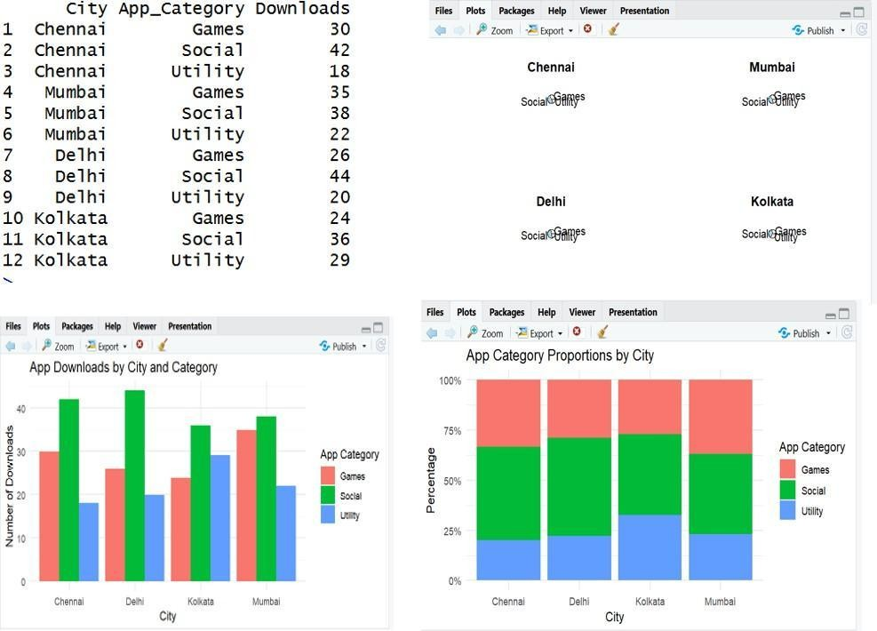

Proportion Visualization

  - Original visualization used separate pie charts for each city.

  - Pie slices are difficult to compare across multiple charts.

  - Exploded slices can exaggerate the importance of categories.

  - Different colors for the same category can confuse users.

  - Side-by-side bars are useful for comparing actual downloads.

  - A 100% stacked bar chart is useful for comparing proportions.

  - The 100% stacked bar chart is better for city-wise proportion comparison.

  - Consistent colors improve interpretation.

Question 4 – Critique and Redesign Nested Proportions
Dataset: Campus_Expenditure.csv

Dataset:

Campus | Department | Expense_Type | Amount
Campus A | Engineering | Faculty Salary | 62000
Campus A | Engineering | Lab Equipment | 34000
Campus A | Management | Faculty Salary | 28000
Campus A | Management | Guest Lectures | 15000
Campus B | Engineering | Faculty Salary | 54000
Campus B | Engineering | Lab Equipment | 40000
Campus B | Management | Faculty Salary | 24000
Campus B | Management | Guest Lectures | 17000
Campus C | Engineering | Faculty Salary | 66000

Campus C | Engineering | Lab Equipment | 31000
Campus C | Management | Faculty Salary | 26000
Campus C | Management | Guest Lectures | 19000

Assessment Task
A finance office uses a treemap to communicate Campus → Department → Expense Type spending. Small areas have unreadable labels and the color scale does not clearly communicate the hierarchy.
- Create the original treemap.
- Critique the size, labeling, color, and hierarchy encodings.
- Redesign the visualization as an improved treemap.
- Create a sunburst alternative and compare it with the redesigned treemap.
- Recommend one visualization for a board presentation and justify your choice.
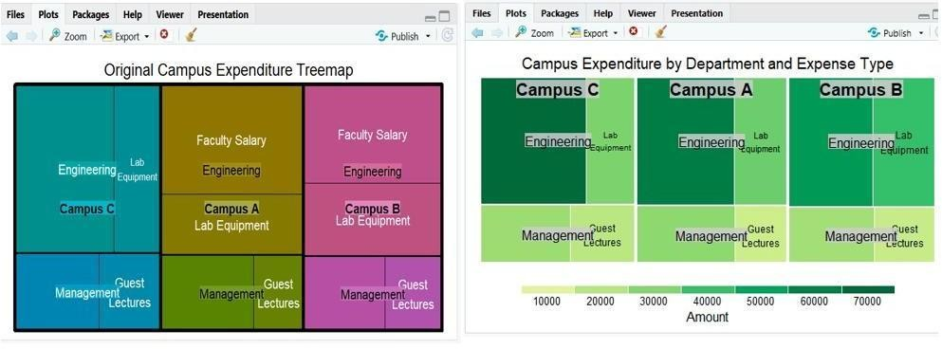

Nested Proportions
  - The data follows the hierarchy: Campus → Department → Expense Type.
  - The original treemap may contain small areas with unreadable labels.
  - Small rectangles are difficult to compare accurately.

  - The color scheme may not clearly show the hierarchy.
  - The improved treemap uses clearer labels and boundaries.
  - A sunburst chart can also represent the hierarchical structure.
  - The sunburst is better for understanding relationships between levels.

The treemap is better for comparing expenditure amounts.
  - Treemap is recommended for a board presentation.

Question 5 – Critique and Redesign Flow-Based Proportions
Dataset: Course_to_Career_Flow.csv

Dataset:

Course | Certification | Job_Role | Students
Data Science | Yes | Analyst | 22
Data Science | Yes | Engineer | 14
Data Science | No | Analyst | 9
Web Development | Yes | Frontend Dev | 19
Web Development | Yes | Backend Dev | 11
Web Development | No | Frontend Dev | 7
Cloud Computing | Yes | DevOps Engineer | 17
Cloud Computing | Yes | Cloud Analyst | 10
Cloud Computing | No | Support Engineer | 6
UI/UX Design | Yes | Product Designer | 13
UI/UX Design | Yes | UX Researcher | 8

UI/UX Design | No | Product Designer | 5

Assessment Task
A training institute uses a Sankey diagram to show Course → Certification → Job Role. The original chart uses near identical colors, unlabelled flows, and node widths that are difficult to compare.
- Create a Sankey diagram representing the data.
- Identify at least four potential sources of confusion or misleading interpretation.
- Redesign the Sankey diagram with meaningful labels, consistent flow representation, and an appropriate visual hierarchy.
- Create a parallel sets alternative and compare the two designs.
- Explain which visualization better communicates the major student career flows and why.

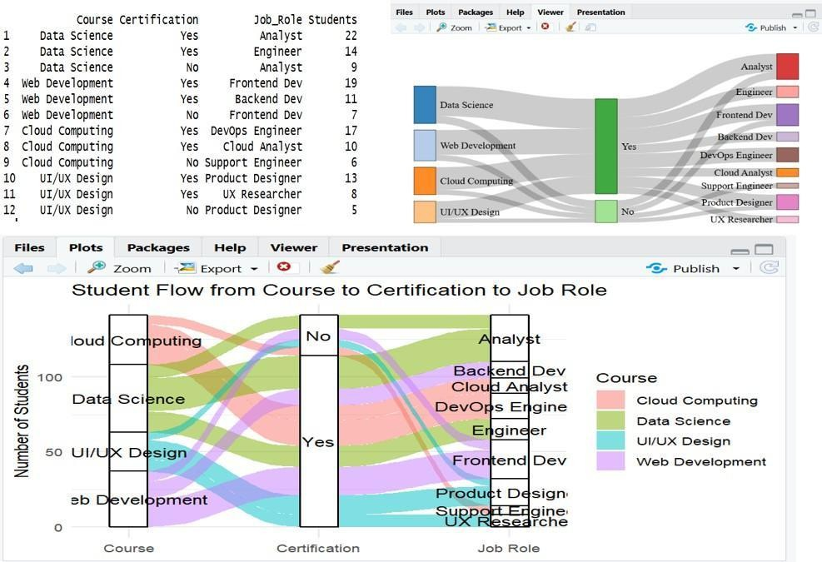

Flow-Based Proportions
  - The data represents Course → Certification → Job Role.
  - A Sankey diagram shows the movement of students between stages.
  - Similar colors can make different flows difficult to distinguish.
  - Unlabelled flows can hide the actual number of students.
  - Flow crossings can create confusion.
  - The redesigned Sankey uses clear labels and meaningful flow representation.
  - A parallel sets plot is an alternative visualization.
  - Sankey is better for showing flow magnitude.
  - Parallel sets are better for comparing categorical pathways across all stages.

